DATE- 03/08/22

**India Mobile Congress 2022 (IMC 2022)**

* *Hon'ble Prime Minister Narendra Modi launched 5G services in India at the India Mobile Congress on 1st October 2022.*
* *A four-day event in October month where leading telecom companies such as Reliance Jio, Bharti Airtel and Vodafone Idea talked about gear makers, tower providers and ecosystem players who showcased their technologies and use cases on 5G.*
* *It was an overwhelmed event with such an amazing participation of students and all professionals*

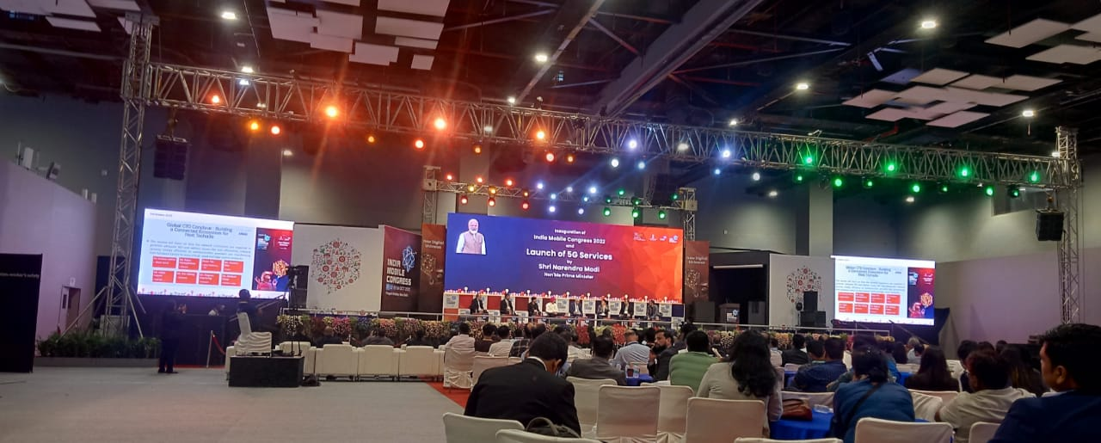

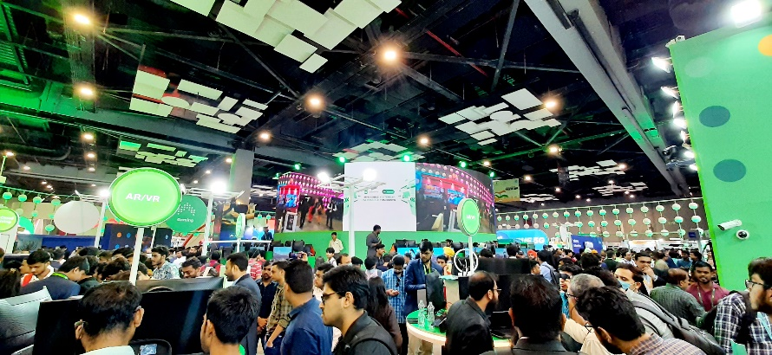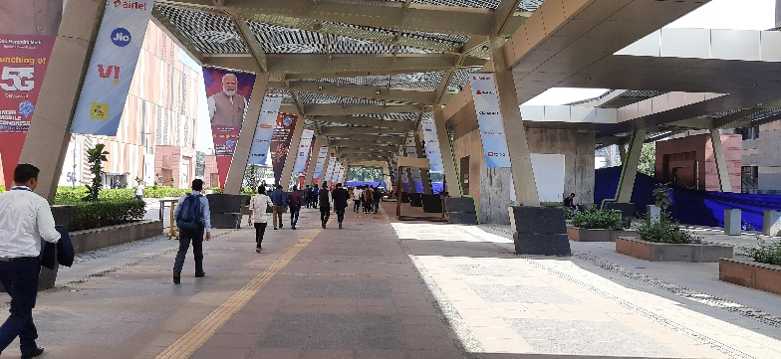

* **ENTERTAINMENT and GAMING Industry**
* Jio Games and JioTrue5G organized eSports tournaments along with rolling out the 5G Service.
* Games like Valorant, Apex Legends Mobile, COD Mobile, FIFA 2023, COD Warzone, Street Fighter 5, and more were featured at IMC 2022

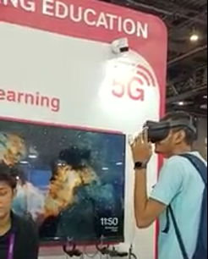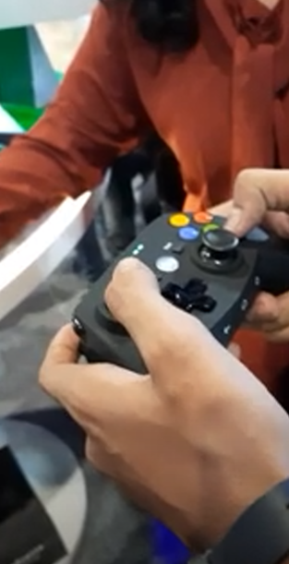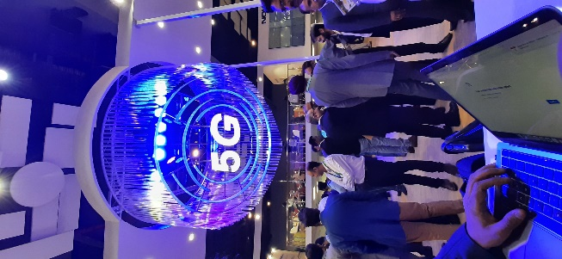

* **Use of Robots in MEDICAL, HOSPITALITY, INVENTORY MANAGEMENT**

The patient in a rural area can perform an ultrasound as well as X-RAY in realtime.

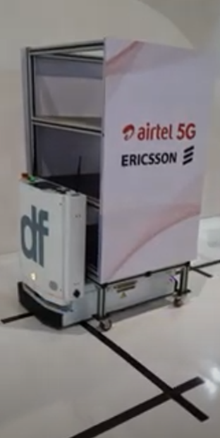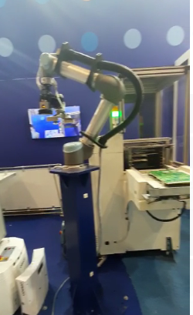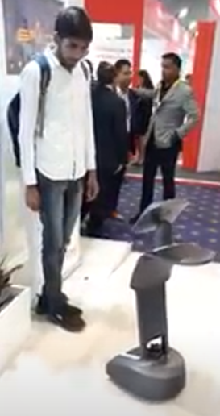

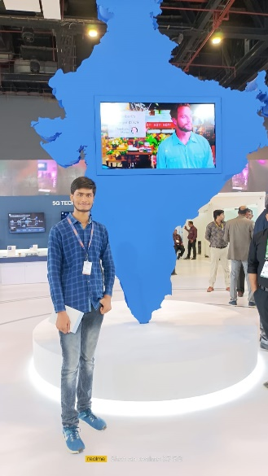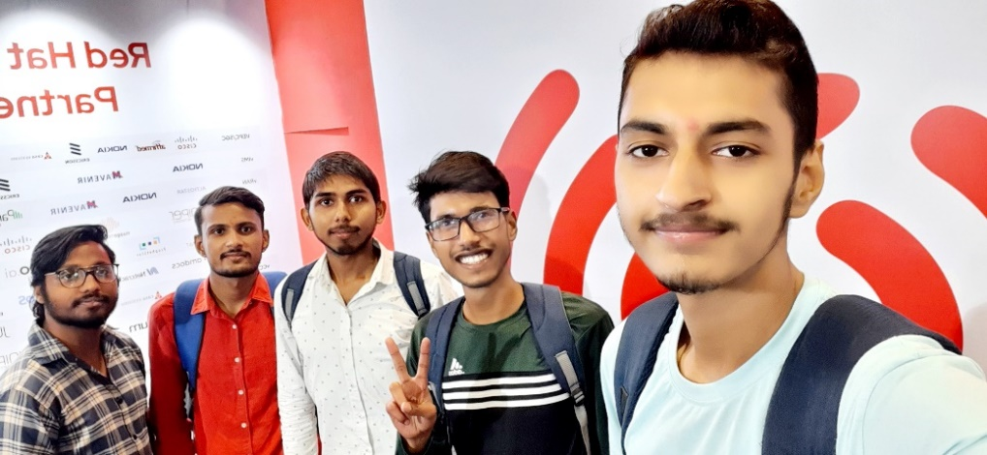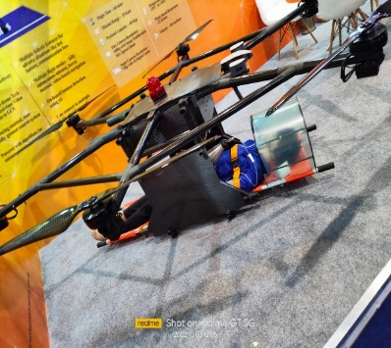

* **Use of Drones in RESCUE OPERATIONS &**

**Successfully Spreading awareness of DIGITAL INDIA**

* The company has displayed a 5G-connected ambulance which as per the telecom giant, can transmit all vital information of patient inside the ambulance to the Hospital in realtime so that the doctor can make necessary arrangements before his/her arrival.
* 5G can play a vital role in saving people’s lives in its booth